**MPOMA SCHOOL MUKONO**

**S.2 MID TERM TWO EXAMS 2022**

**PHYSICAL EDUCATION**

**TIME: 2HRS**

**INSTRUCTIONS**

This paper has three sections. Section A, B and C

Section A has 20 objective type questions, section B has two structured type questions and section c has two essay questions

Circle the correct answer for section A and attempt all questions in B and C

Attempt all questions

**SECTION A (20MKS)**

1. The following are activities involved in educational gymnastics except.
2. Body shapes
3. Cart wheel
4. Hand stand
5. None of the above
6. The player in position **………..** Serves the ball in volleyball.
7. 1
8. 2
9. 3
10. 5
11. **………………**is a social benefit of engaging in in physical education.
12. Reduces stress
13. Promotes friendship
14. Reduces feeling of depression
15. Helps control weight
16. What is the maximum number of players on each team in a volleyball game
17. 4
18. 9
19. 7
20. 6
21. The act of helping someone to successfully perform certain gymnastic activities is called**……..**
22. Gymnastics
23. Spying
24. Spotting
25. Helping
26. Which of the following is a similarity between games and sports?
27. Both individual participants in games and sports are called players
28. Both have require a lot of mental strength
29. Both have rules to be followed
30. Both are played mainly for competition
31. …………….is an attacking skill of volley ball.
32. Spiking
33. Blocking
34. Digging
35. None of the above
36. The individual participant in a game is called a player while as the individual participant in a sport is called **……………….**
37. Athlete
38. Boxer
39. Player
40. coach
41. An easy exercise done after a more intense activity to allow the body to gradually transition to resting or near resting state is called
42. Warm up
43. Cool down
44. Resting
45. training
46. In case one is not breathing, or has no pulse we apply CPR. What is CPR in full.
47. Cardio pulmonary resuscitation
48. Pulmonary resuscitation
49. Cardio resuscitation pulmonary
50. None of the above
51. Which of the following is a rule used in the game of volleyball.
52. A player must not block or attack a serve
53. The net should not be touched during play
54. Each team can have a maximum of 6 players on court
55. All the above
56. **………**is an example of a loco motor skill in gymnastics
57. Running
58. Press ups
59. Side support
60. Front support
61. …**……………….**is a local material used to give first aid for cuts.
62. Banana leaves
63. Black jack leaves
64. Ice
65. Piece of wood splints
66. The following are reasons for giving first except
67. To save life
68. To reduce pain
69. For quick recovery
70. None of the above
71. Which of the following is a reason for icing the injured part for a person having a sprain?
72. To reduce pain
73. To stop bleeding
74. To save life
75. To stop movement of the injured part
76. The volley ball court has a length of?
77. 18m
78. 7m
79. 4m
80. 14m
81. Which one of the following is a phase of cool down
82. General phase
83. Immediate phase
84. Dynamic stretching exercise phase
85. Sport specific exercise phase
86. Which one of the following is an importance of spotting in gymnastics
87. Reduces fear
88. Reduces risk of injury
89. Improves ones performance
90. All the above
91. While checking for circulation of blood, one should?
92. Put the cheek near the casualty’s nose
93. Check for the pulse
94. Touch the patient’s abdomen to see if there is any raise and fall
95. Touch on the casualty’s head
96. Exercises involving shifting your weight from one part of the body to another are called?
97. Weight bearing exercises
98. Transference of weight exercises
99. Loco motor exercises
100. None of the above

**SECTION B (20 MKS)**

21a. State two differences between a sport and a game (4mk)

**………………………………………………………………………………………………………………………………………………………………………………………………………………………………………………………………………………………………………………………………………………………………………………………………………………………………………………………………………………………………………………………………………**

b. Give any two health, social and mental benefits of engaging in physical education (6mks)

Health

**………………………………………………………………………………………………………………………………………………………………………………………………………………**

**………………………………………………………………………………………………………………………………………………………………………………………………………………**

**Social**

**………………………………………………………………………………………………………………………………………………………………………………………………………………………………………………………………………………………………………………………………………………………………………………………………………………………………mental**

**………………………………………………………………………………………………………………………………………………………………………………………………………………………………………………………………………………………………………………………………………………………………………………………………………………………………**

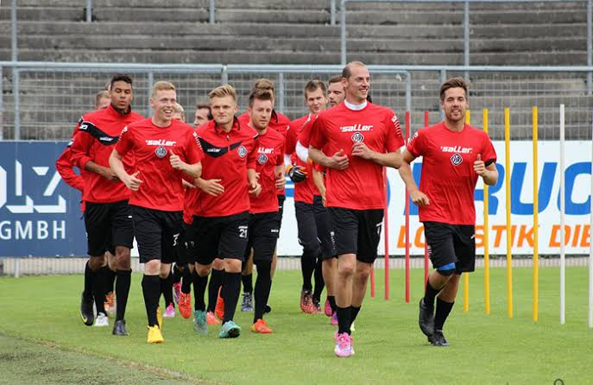

22a. what do you understand by the term warm up? (1mks)

**………………………………………………………………………………………………………………………………………………………………………………………………………………………………………………………………………………………………………………………**

b. Identify any three phases of warm up. (3mks)

**………………………………………………………………………………………………………………………………………………………………………………………………………………………………………………………………………………………………………………………………………………………………………………………………………………………………**

C. State any five activities involved in a warm up session (5mks)

**………………………………………………………………………………………………………………………………………………………………………………………………………………………………………………………………………………………………………………………………………………………………………………………………………………………………………………………………………………………………………………………………………………………………………………………………………………………………………………**

d. what do you understand by the term cool down (1mk)

**………………………………………………………………………………………………………………………………………………………………………………………………………………**

**SECTION C (20mks)**

23. Supposing elders in your village have organized a volleyball Easter competition but don't know how to mark the volleyball court and the rules of the game. Assuming the elders requested you to teach them all they didn't know about.

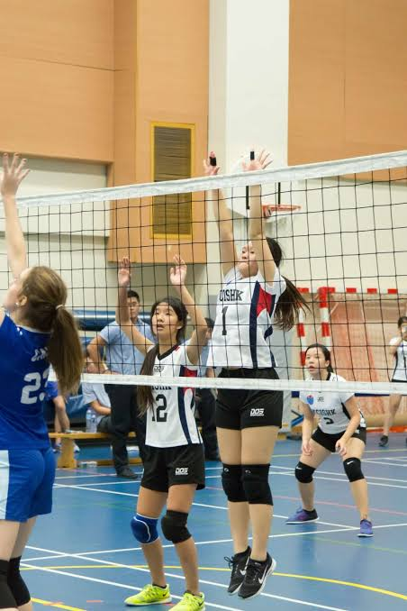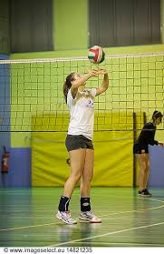

**Task**

Make a write up on how you would get the job done.

24. During the sports day at Mpoma School, students sustained several injuries like cuts, bruises, fainting, sprains, bruises, fractures yet the students were not aware of how to give first aid for those injuries.

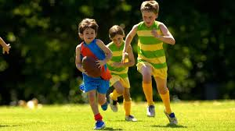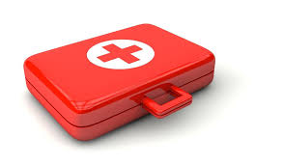

**Task**

Make a write up that will be used as a poster to inform students on how to give first aid.

**END**